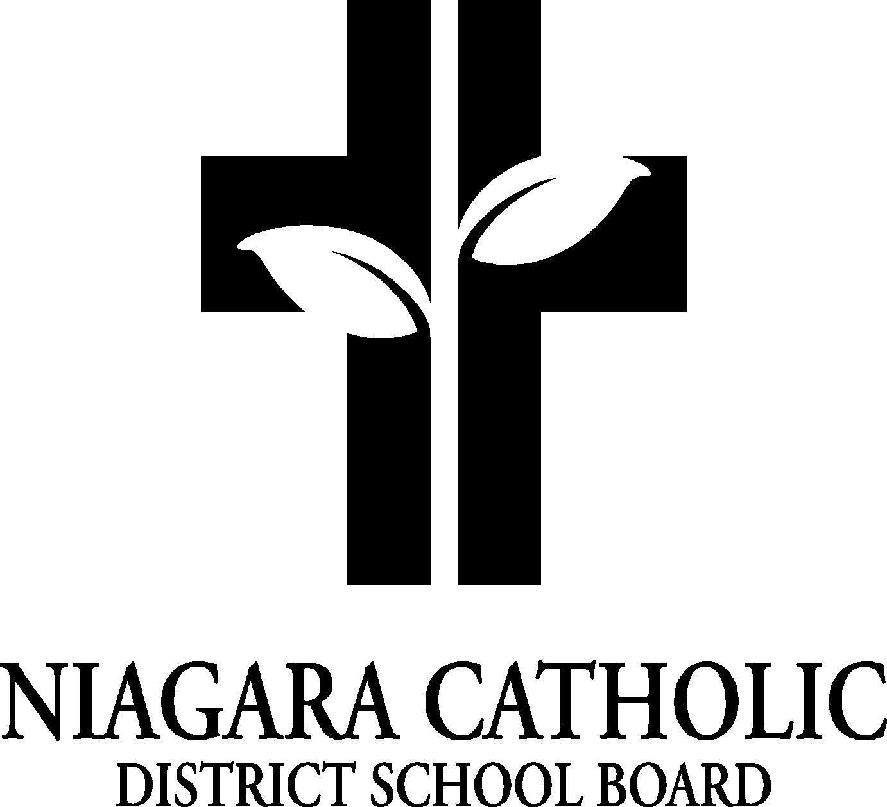

MINUTES OF THE
ST. JOSEPH CATHOLIC SCHOOL COUNCIL MEETING

SEPTEMBER 18, 2013

Minutes of the Meeting of the St. Joseph Catholic School Council, held on September 18 at 6:00 pm.

The meeting was called to order at 6:00 pm by Chair Sandra Skingley.

A. ROUTINE MATTERS

1. Opening Prayer

The opening prayer was led by Diane Pizale, Acting Principal

2. Roll Call

Members | Affiliations | Present | Excused | Absent
June Watchorn | Chair |  X
Diane Pizale, Acting Pr. | Secretary/Treasurer-Principal-Lorrie MacKenzie |  X
Carol Brunton | Recording Secretary |  | X
Carm Bernardi | Teacher Representative | X
Franca Beifuss | Bingo | X
Sandra Skingley | Breakfast Programme, Thanksgiving, ECO | X
Brenda Miszk |  | X
Kelly DiLapo  apo | Bingo | X
Maria Arnott | Bingo Treasurer |  |  | X

3. Approval of the Agenda

Moved by: Sandra Skingley
Seconded by: Kelly DiLapo
THAT the St. Joseph Catholic School Council approves the Agenda of the St. Joseph Catholic School Council Meeting of September 18, 2013
CARRIED

4. Disclosure of Interest

No Disclosures of Interest were declared with any items on the agenda.

5. Approval of Minutes of the St. Joseph Catholic School Council Meeting of April 5, 2013

Moved by: Sandra Skingley
Seconded by: Kelly DiLapo
THAT St. Joseph Catholic School Council approves the Minutes of the St. Joseph Catholic School Council Meeting of April 5, 2013 as presented (on St. Joseph website).
CARRIED

B. PRESENTATIONS-Good News

- Curriculum Night Attendance
- Dress Code-smooth transition at St. Joseph Catholic School
- A huge thank you to St. Joseph Catholic School Council for providing EACH student a dress code shirt (St. Joseph Spirit Wear).

- BUSINESS ARISING FROM THE MINUTES OF THE MEETING April 5, 2013
- N/A (minutes of April 5, 2013)
- Election of St. Joseph CSC members (2013-2014)
- All members present at meeting agree to be part of St. Joseph CSC.
- Ms. June Watchorn was acclaimed as St. Joseph Catholic School Chair
- Mrs. Carol Brunton was nominated for Recording Secretary and accepted but was excused from this meeting because of a prior appointment. Ms. Pizale would be the recording secretary for this meeting
- Subcommittee Members for the 2013-2014 are as follows:
- Breakfast Programme-Sandra Skingley (Returning and new parent helpers, schedule in place and programme has begun)
- Bylaws-Kelly DiLapo (to be reviewed and if no changes to follow will be adapted October 2013)
- Fundraising/Bingo-Kelly DiLapo (Discussed new ways to elicit volunteers for Bingo; the Bingo venue will be changing in the Winter, less volunteer numbers would be needed).
- Policy-Principal to review with St. Joseph CSC
- Community Outreach-Sandra Skingley
- ECO/Garden-Sandy Skingley (Peace Garden needs attention. St. Joseph Catholic School Council would like to acknowledge our neighbour “Angel” who tirelessly keeps are school yard lawns cut).

E. PRINCIPAL’S REPORT
- School Fundraiser (Magazine). Goal to raise monies for Water Hydration Station
- NPIC Elections-information discussed and distributed.
- EQAO results

F. FINANCIAL REPORT
- Financial Report was presented to St. Joseph CSC

G. REPORT FROM STAFF REPRESENTATIVE (C. Bernardi)
- Grade 7/8 NorCard Fundraiser, Grade 4 Bible Blessing-October 18, Holy Childhood Walk-October 24, Mass/Luncheon-October 9, Cross County and Soccer starting.

H. NEW BUSINESS/QUESTIONS
- Consider another Spirit Wear order for Winter

P. NEXT MEETING: NCPIC Annual Catholic School Councils Chair and Members’ Meeting-October 23, 2103 (Monsignor Clancy Catholic School), November 23 @ 6:00 pm.

Q. ADJOURNMENT
Moved by: Franca Beifuss
Seconded by: Brenda Miszk
THAT the September 18, 2013 meeting of the St. Joseph Catholic School Council be adjourned.
CARRIED

This meeting was adjourned at 7:20

R. CLOSING PRAYER: was led by ALL

